**ABSTRACT:**

Agriculture is a cornerstone of global food security and economic growth. Accurate crop yield prediction is essential for optimizing resource allocation, improving agricultural planning, and addressing the challenges of global food security. Machine learning techniques, particularly the Decision Tree algorithm, have emerged as powerful tools for forecasting crop yields. By analysing historical crop yield data in combination with meteorological and agricultural variables, these models enhance prediction accuracy. The Decision Tree algorithm is especially effective due to its ability to handle both categorical and continuous variables, making it suitable for uncovering complex relationships within the data. This integration of agriculture with data science offers a promising pathway for promoting sustainable farming practices and supporting informed decision making on a global scale.The core of the project is the Decision Tree algorithm, a robust and interpretable machine learning technique well-suited for solving classification and regression problems. By analyzing historical data, including factors such as temperature, rainfall, soil composition, and fertilizer usage, the model is trained to predict the potential yield for a variety of crops. This project leverages key data preprocessing techniques, including scaling with StandardScaler and feature encoding using One-Hot Encoding (OHE), to enhance the model's accuracy and efficiency. To improve user accessibility, a web-based interface has been developed using Flask, with the front-end built using HTML, CSS, and Bootstrap. This interface allows users to input relevant data and receive real-time crop yield predictions, making the tool practical for farmers, agricultural researchers, and decision-makers worldwide. The prediction results are easy to interpret, enabling users to make proactive decisions in response to environmental changes or market demands.One of the critical challenges addressed in this project is the need for accurate crop yield predictions across diverse geographies and climatic conditions. By training the model on international datasets and employing cross-validation techniques, the project ensures that the predictions are generalizable across different regions. This global approach is aimed at helping not only local farmers but also contributing to solving global food challenges. Moreover, the model is designed to be scalable, allowing it to be trained on datasets from different regions across the world. By incorporating diverse climatic, geographical, and agricultural conditions, the project aims to create a globally applicable model that can predict crop yields for various types of crops in different regions. This international approach is particularly important for addressing the global food crisis and ensuring food security in regions that are more vulnerable to climate change and other environmental risks. With the integration of machine learning, user-friendly web interfaces, and global datasets, the project has the potential to make a significant impact on modern agriculture, supporting sustainable development goals and reducing the risks associated with climate variability and resource management.

**CHAPTER 1**

**INTRODUCTION**

**Introduction:**

Crop yield prediction is a crucial aspect of modern agriculture, combining technological advances with agricultural science to enhance productivity and ensure food security. As the global population continues to grow, the demand for food increases, placing immense pressure on agricultural systems. Accurately predicting the quantity of crops that can be harvested from a given area of land empowers farmers, agronomists, and policymakers to make informed decisions regarding resource allocation, market strategies, and food distribution. This proactive approach enables stakeholders to optimize farming practices and meet the nutritional needs of the population effectively.

With the increasing availability of data and advancements in machine learning, crop yield prediction has evolved significantly from simple statistical models to sophisticated algorithms capable of analyzing a wide array of influencing factors. Modern predictive models take into account not just basic inputs but also complex interactions between various variables, including weather conditions, soil characteristics, seed quality, agricultural practices, and historical crop performance. This multifaceted analysis allows for a more comprehensive understanding of the factors that affect crop yields, leading to more accurate predictions and better planning.

Machine learning techniques, such as Decision Trees, Random Forests, and Neural Networks, have proven particularly effective in crop yield prediction. These algorithms excel at identifying complex patterns within large datasets, learning from the nuances of each variable to make informed predictions. For instance, Decision Trees can illustrate how different factors contribute to yield outcomes, while Random Forests can aggregate predictions from multiple trees to improve accuracy. Neural Networks, on the other hand, can model intricate relationships within the data, providing deep insights into how various elements interact over time. By leveraging these machine learning techniques, agricultural stakeholders can anticipate crop production outcomes with greater reliability, optimizing their farming practices accordingly.

The implications of employing predictive models in agriculture extend far beyond individual farms; they play a significant role in enhancing agricultural efficiency and sustainability on a global scale. With accurate yield predictions, farmers can better manage risks associated with climate variability and environmental changes, allowing for timely adjustments to their practices. This adaptability not only increases profitability for farmers but also contributes to overall food security by ensuring that supply aligns more closely with demand. By harnessing the power of machine learning in crop yield prediction, the agricultural sector can take significant strides toward sustainable practices that support both the economy and the environment, ultimately helping to feed the world's growing population.

**1.1 OVERVIEW :**

Crop yield prediction is a vital process that estimates the agricultural output of a specific piece of land, serving as a critical tool for farmers, agricultural planners, and policymakers. Accurate yield predictions enable stakeholders to optimize resource allocation, manage supply chains effectively, and make informed decisions about crop management and planting schedules. Traditionally, yield estimation has relied heavily on historical data and expert judgment, which can be limited in precision due to various environmental factors such as climate variability, soil health, and farming practices. These traditional methods often struggle to account for the dynamic and multifaceted nature of agricultural ecosystems, leading to suboptimal decisions that can impact food production and sustainability.

In contrast, machine learning presents a transformative approach to crop yield prediction by harnessing the power of advanced algorithms to analyze vast amounts of complex data. By integrating diverse datasets, including soil quality indicators, real-time weather conditions, crop management practices, and satellite imagery, machine learning models can identify intricate patterns and correlations that traditional methods may overlook. These models can adapt to changing conditions, making predictions more reliable and scalable across different geographical regions and crop types. In your project, machine learning is leveraged to predict yields, with the results seamlessly displayed on a dedicated web interface. This modern, data-driven solution not only enhances the accuracy of yield predictions but also provides farmers and stakeholders with timely insights that can significantly improve agricultural outcomes, ultimately contributing to increased productivity and food security.

**1.2 PROBLEM DEFINITION:**

Agriculture plays a crucial role in feeding the global population, yet farmers and agricultural planners face significant challenges in predicting crop yields due to varying environmental conditions, soil characteristics, and agricultural practices. Traditional prediction methods, which rely on historical trends or expert assessments, are often limited in accuracy and adaptability, especially when dealing with large datasets and rapidly changing factors like climate. These methods can lead to misestimations that affect food supply chains, resource management, and economic viability for farmers. To address these challenges, the goal of this project is to develop a machine learning-based system that can accurately predict crop yield by analyzing relevant factors such as weather conditions, historical crop data, average temperature, and pesticide use. By integrating these diverse inputs, the system will provide reliable and timely predictions, enabling farmers to make better-informed decisions regarding resource allocation, crop management, and financial planning.

The project also focuses on creating a user-friendly web interface to present the predicted yield values clearly and effectively. This interface will allow users to interact with the model easily, inputting their specific parameters and receiving tailored predictions. By displaying the results in an accessible format, the system aims to bridge the gap between complex machine learning algorithms and practical agricultural decision-making. Ultimately, this project seeks to address the shortcomings of imprecise and outdated prediction methods by leveraging advanced machine learning techniques to deliver more accurate, scalable, and adaptable solutions for crop yield forecasting. In doing so, it aims to empower farmers and stakeholders with the insights needed to enhance agricultural productivity, improve food security, and foster sustainable farming practices.

**CHAPTER 2**

**LITERATURE SURVEY**

1. In this study, Aruvansh Nigam, Saksham Garg, Parul Agarwal, and Archit Agarwal concentrate on crop yield prediction through various machine learning algorithms. The results of this approach are evaluated using mean absolute error. Algorithms such as RNN and LSTM are utilized to ensure precise outcomes, helping farmers decide which crops are most advantageous to cultivate.
2. The authors propose employing a deep reinforcement learning model for accurate crop yield estimation. Features that contribute to predictions are extracted using deep learning techniques, and the Q-learning method is applied, allowing the reinforcement learning algorithm to learn from user interactions and collaborations.
3. This publication discusses the use of machine learning for predicting crop yields, applicable to almost any Indian crop. To meet its objectives, the research incorporates sophisticated algorithms like Kernel Ridge, Rasso, and Enet. Additionally, regression stacking is employed to improve prediction accuracy. The project monitors performance through root mean squared error, enabling users to input metric values for generating prediction results.
4. In this research, Shivam Bang, Akshaya Kumar Dixit, Rajat Bishnoi, Indu Chawla, and Ankit Singh Chauhan explore crop yield prediction by analyzing rainfall and temperature as significant factors. They employ ARMA, SARIMA, and ARMAX models to improve prediction accuracy, followed by the application of fuzzy logic once the predictions are established. This approach relies on previous year’s crop yield data to estimate yields for the upcoming year.
5. Niketa Gandhi et al. present a system for estimating rice crop yield in India using the support vector machine (SVM) algorithm. They applied Sequential Minimal Optimization (SMO) classifiers within WEKA software to analyze the given datasets. The results from their analysis were integrated into the final conclusions, highlighting the classifiers' effectiveness in accurately predicting rice production.
6. In this research, the authors introduce a crop prediction method that accounts for soil and weather conditions to determine the crops best suited for a specific environment. They employ an artificial neural network (ANN) to achieve the intended results. The network learns from sample input and output data using a backpropagation technique, which is trained through supervised learning.
7. Authors D. Ramesh and B. Vishnu Vardhan proposed a crop yield prediction technique using data mining processes, which are extensively applied to agricultural issues. This method is used for classifying and identifying patterns within large datasets. The model for predicting crop yields was developed using the Multiple Linear Regression (MLR) method.
8. In this study, researchers B. Manjula Josephine et al. propose a system for predicting crop yields using machine learning. They input a crop yield dataset and apply data preprocessing techniques to transform the raw data into a more understandable format. Next, a random forest approach is employed, which involves data validation and forecasting to achieve accurate results. Additionally, dimensional reduction is conducted to reduce the number of random variables.
9. This study recommends a combined approach to feature selection that integrates both filter and wrapper strategies. By merging soil, crop, and meteorological data, the study creates optimal features for a crop recommendation algorithm. Model performance is evaluated by comparing dataset features with those generated from the proposed method. The effectiveness of the feature selection technique is assessed using metrics like MSE, RMSE, MAE, and R2. Using the selected features, artificial neural networks and decision trees are developed.

**CHAPTER 3**

**MATERIALS AND METHODS**

The successful development of a crop yield prediction model requires a comprehensive understanding of the materials and tools at our disposal, as well as the development environment in which the project will be executed. In this section, we will explore the dataset description, providing insights into the various factors influencing crop yields, and delve into the development environment, highlighting the technology stack and tools that will facilitate the project.

* 1. **Dataset Description**

The dataset for crop yield prediction includes several key features that provide essential insights into the factors influencing agricultural output. Key attributes include Area, which represents the total land area (in hectares) dedicated to crop cultivation, and Item, specifying the type of crop grown, such as wheat, rice, or maize. The Year field indicates the time frame of the data, essential for analyzing trends over time. The yield is quantified in hg/ha_yield, reflecting the quantity produced per hectare, while average_rain_fall_mm_per_year provides information on the average annual rainfall, crucial for understanding water availability. Additionally, pesticides_tonnes denotes the total amount of pesticides used, and avg_temp records the average temperature during the growing season, both of which significantly impact crop health and yield.

This structured dataset allows for a comprehensive analysis of the relationships between environmental factors, agricultural practices, and crop productivity. Each row in the dataset represents a unique observation for a specific crop in a given year, enabling the application of statistical and machine learning techniques to predict crop yields effectively. By carefully preprocessing and analyzing these features, the dataset serves as a foundational resource for developing a robust crop yield prediction model that can help optimize agricultural practices and improve food security.

* 1. **Development Environment Front-end Technologies:**

Creating an engaging and responsive website necessitates the use of cutting-edge front-end technologies. Our development environment relies on a combination of HTML, CSS, and JavaScript. HTML, as the structural foundation, provides the framework upon which our website is built. CSS takes the helm in designing and styling the web pages, ensuring a visually pleasing and cohesive layout. JavaScript, the dynamic scripting language, infuses interactivity and responsive behavior into the website. These technologies collectively make the website not only visually engaging but also user-friendly and accessible on various devices, including desktop computers, tablets, and smartphones.

**Bootstrap:**

Bootstrap simplifies the process of creating a responsive and mobile-friendly design for your web application. It provides a flexible grid system that helps organize content in a structured and responsive layout. Bootstrap also offers pre-designed components such as buttons, navigation bars, and form inputs, allowing for faster development with a professional look. Its utility classes make styling easier by providing predefined options for margin, padding, alignment, and other properties, ensuring that your application is modern, visually appealing, and easy to navigate.

**Back-end Technologies:**

The backend development of model utilizes a combination of powerful tools and frameworks to facilitate data processing, model training, and deployment. Jupyter is employed for exploratory data analysis and visualization, allowing for interactive coding and immediate feedback, whichis essential for understanding data patterns and relationships. It provides an intuitive environment for experimenting with different machine learning algorithms and refining the predictive model.

**Flask:**

Flask, a lightweight web framework for Python, is used to build the web application’s backend. It handles HTTP requests, manages routing, and serves the model's predictions through a RESTful API. This allows seamless interaction between the front-end interface and the machine learning model. Python, the core programming language, is utilized for data manipulation, model training, and implementation of machine learning libraries such as Pandas, NumPy, and Scikit-learn. Finally, PyCharm serves as the integrated development environment (IDE), providing robust features for code editing, debugging, and project management, ensuring efficient development workflows and enhanced productivity. This combination of technologies empowers the backend of the crop yield prediction project, enabling accurate predictions and effective user interaction.

# SEARCH AND FILTER FUNCTIONALITY

**Search Functionality:**

The search functionality allows users to easily find specific crops or yield data within the e-commerce platform or crop yield prediction application. This feature can be implemented using a search bar where users can input keywords related to crops, such as the crop name or year of interest. The backend, powered by Flask, can query the dataset based on user input, returning relevant results quickly. This enhances the user experience by allowing for efficient navigation through the extensive product catalog or yield predictions, ensuring users can easily access the information they need.

**Filter Functionality:**

The filter functionality further refines the search results by allowing users to narrow down options based on various criteria. In the context of crop yield prediction, users might filter results based on factors such as crop type, geographical area, year, or environmental conditions (like average rainfall or temperature). This can be achieved through dropdown menus or checkboxes in the user interface, where users can select their desired parameters. The backend can then dynamically adjust the dataset query to display only the relevant results, making it easier for users to analyze data and make informed decisions based on specific criteria.

**Development Tools:**

The development tools used in the project play a crucial role in ensuring a smooth and efficient development process. Jupyter is utilized for data analysis and experimentation, allowing for interactive coding and visualization. Flask provides the web framework necessary for building the backend API, while Python serves as the primary programming language for implementing data processing and machine learning algorithms. PyCharm acts as the integrated development environment (IDE), facilitating code editing, debugging, and project management. These tools together create a robust environment for developing, testing, and deploying the crop yield prediction model.

**Version Control:**

Version control is essential for managing changes to the project’s codebase and ensuring collaboration among team members. Git is commonly used as the version control system, allowing developers to track changes, create branches for new features or bug fixes, and maintain a history of modifications. Platforms like GitHub or GitLab provide a centralized repository for hosting the code, enabling collaboration, code reviews, and issue tracking. Implementing version control helps maintain code integrity and facilitates smoother development workflows, particularly in team settings.

**Testing and Quality Assurance:**

Testing and quality assurance are critical components of the development process to ensure the reliability and accuracy of the crop yield prediction model. Unit tests can be written for individual functions and components to verify their correctness, while integration tests can ensure that different parts of the application work seamlessly together. Flask provides testing tools to simulate requests and validate responses from the API. Additionally, continuous integration (CI) tools can automate testing processes to identify issues early in the development cycle.

**CHAPTER 4**

**SYSTEM MODEL**

The system model for the crop yield prediction project is crucial for ensuring accurate predictions and efficient data handling. This section outlines the preprocessing steps applied to the dataset, including data cleaning, normalization, and feature selection, which are essential for preparing the data for machine learning algorithms.

**DATA CLEANING AND VALIDATION:**

Data cleaning and validation are crucial preprocessing steps in the crop yield prediction project, ensuring that the dataset is accurate and reliable for analysis. This process involves identifying and handling missing values, which may be addressed through imputation techniques, such as filling gaps with the mean, median, or mode, or by removing rows or columns with excessive missing data. Outliers are also examined and addressed to prevent skewing the model’s predictions; this may involve removing outliers or transforming data to reduce their impact. Furthermore, data validation checks are performed to ensure that the values within the dataset conform to expected formats and ranges, enhancing the dataset's overall integrity. By thoroughly cleaning and validating the data, the foundation is laid for more accurate and robust yield predictions.

**4.1 CATEGORIZATION AND TAXONOMY:**

Categorization and taxonomy play a significant role in organizing the dataset for crop yield prediction. This process involves classifying crops into distinct categories based on specific attributes, such as crop type (e.g., cereals, legumes, vegetables) or growth requirements (e.g., temperature, soil type). By establishing a clear taxonomy, the dataset becomes easier to analyze, allowing for targeted predictions based on specific crop characteristics. Additionally, categorization facilitates the exploration of relationships between different variables, such as the impact of rainfall on specific crop types. This structured organization not only enhances data analysis but also enables the development of more tailored and effective predictive models, ultimately improving the accuracy of yield predictions.

**4.2 EXISTING SYSTEM:**

A regression method has been applied in one of the existing systems for crop analysis. This system examined over 362 datasets, combining classification with decision tree analysis to provide solutions. For soil type prediction, the input data was divided into categories like natural, inorganic, and land. The results were consistent and reliable. Data management played a key role in collecting test data from another system during the study. Back Propagation Networks employed hidden layers to improve the accuracy of soil property predictions. Additionally, SVM and RVM were used as supervised learning techniques for predicting soil quality. Meteorological data was utilized to measure soil moisture through advanced remote sensing technologies, achieving 95% accuracy with a 15% error rate, though it hasn't yet been validated with the latest data. Basic engineering calculations were used to assess soil fertility and plant nutrient availability, leading to precise results and enhanced soil properties. While this approach yielded better outcomes than traditional methods, the system showed occasional inefficiencies. Essentially, this system uses soil factors to optimize crop yields. Currently, Naive Bayes classification is applied for soil categorization, achieving 77% accuracy. Additionally, Apriori algorithms are employed to identify crops with high yield potential based on soil type. It is proposed that the system integrates both crop yield data and environmental factors to predict crop development.

**DISADVANTAGES:** Inaccurate Results, High Computational Complexity.

**CHAPTER 5**

**PROPOSED METHODOLOGY**

The proposed methodology for developing the model for “Crop Yield Prediction” outlines the architectural design and algorithms used to ensure an efficient, scalable, and user-friendly platform. In this section, we delve into the architecture diagram, illustrating the website's structure, and discuss the algorithms that drive its key functionalities.

**PROPOSED SYSTEM:**

The proposed system for crop yield prediction utilizes the Decision Tree Algorithm to analyse various factors influencing yield, such as soil properties, weather conditions, and crop type. The system will collect historical data on crop yields, soil nutrients, and meteorological information, followed by pre-processing steps to clean and normalize the data. The Decision Tree will then be trained on this processed data, allowing it to identify patterns and make numerical predictions about future crop yields based on new input variables. The output will provide a predicted yield value, enabling farmers to make informed decisions about crop management and resource allocation. This approach not only enhances prediction accuracy but also offers a clear and interpretable model that can aid in optimizing agricultural practices.

**Advantages of Proposed System:**

* Improved Prediction Accuracy
* Handles Complex Data
* Scalability
* Preprocessing for Clean Data

**5.1 Architecture Diagram**

This diagram represents a comprehensive data science workflow, beginning with historical data that is subjected to feature engineering. In this process, raw data is preprocessed and transformed to create structured datasets. The data is then split into two sets: train data and test data. The train data is used in the DS Technologies phase, where various data science algorithms are applied to build a predictive model. Meanwhile, the test data is reserved for model validation, ensuring that the model performs well and generalizes effectively to unseen data.

Once the model has been trained and validated, it moves to the Action phase, where it is used to make predictions on new data. This final step generates actionable results that can be applied in decision-making processes or business strategies. The entire workflow highlights a systematic approach to turning historical data into meaningful insights, using data science techniques to guide realworld actions and outcomes.

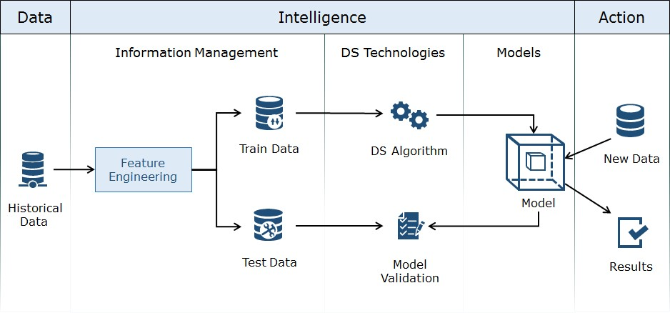

*fig 5.1 Architecture Diagram*

**KEY COMPONENTS:**

1. **Historical Data (Crop Data):**

Historical crop data includes data such as previous yields, soil conditions, weather patterns, and agricultural practices over time. This data serves as the foundation for building a predictive model for crop yield.

1. **Feature Engineering:**

The process of transforming the raw agricultural data into meaningful variables (features) like temperature, rainfall, soil moisture, and fertilizer usage. These features help improve the performance of machine learning models by capturing relevant patterns for yield prediction.

1. **Train Data:**

A subset of the processed data that is used to train the machine learning models. This data includes labeled examples, such as crop yield outcomes corresponding to specific environmental and farming conditions.

1. **Test Data:**

Another subset of the data, reserved for evaluating the model’s performance. The test data is unseen during training, and it provides an unbiased estimate of how well the model can predict future crop yields.

1. **DS Algorithm:**

Data science algorithms such as Decision Trees, Random Forest, or Linear Regression are applied to the train data to create predictive models. These algorithms analyze the relationship between the features and crop yields to make predictions.

1. **Model Validation:**

The validation process involves testing the model on the test data to measure its accuracy and ensure it generalizes well to unseen data. It helps in fine-tuning the model to avoid overfitting or underfitting.

1. **Model:**

After successful training and validation, the model is finalized. This model can now predict crop yields based on input features like weather forecasts, soil data, and farming techniques.

1. **New Data:**

The model is applied to new data (e.g., current season’s weather forecast, soil conditions) to predict the crop yield for the upcoming harvest.

1. **Results:**

The predictions made by the model are used by farmers or agricultural organizations to make informed decisions about planting, irrigation, fertilization, and other factors affecting crop yield. These results help optimize resource usage and maximize productivity.

This structured workflow helps improve the accuracy of crop yield predictions and enables data-driven decision-making in agriculture.

**5.2 ALGORITHM**

**Decision Tree Algorithm:**

The Decision Tree algorithm is a powerful tool for predicting crop yield, enabling data-driven decision-making in agriculture. By analysing historical data and understanding the relationships between various factors, stakeholders can optimize farming practices, resource allocation, and crop management strategies. Its interpretability and ability to handle diverse datasets make it a valuable asset in the field of agricultural analytics.

**Introduction to Decision Trees**

The Decision Tree algorithm is a popular supervised machine learning technique used for both classification and regression tasks. In the context of crop yield prediction, decision trees provide a robust method to model complex relationships between various environmental, agricultural, and economic factors and the resulting crop yield. The intuitive tree-like structure of decision trees allows for easy interpretation and visualization of decision-making processes.

**Structure of Decision Trees**

A decision tree consists of nodes and branches:

**Root Node:** The starting point that represents the entire dataset.

**Internal Nodes**: Each node represents a decision based on a feature. These nodes contain tests or conditions that determine the splitting of data.

**Branches**: Each branch represents the outcome of a decision, leading to further nodes or leaf nodes.

**Leaf Nodes:** The end points of the tree that represent the final prediction (e.g., estimated crop yield).

Working Mechanism

**Data Preparation**: Historical data on crop yields is collected, including various features such as area, type of crop, rainfall, pesticide usage, temperature, and other relevant factors. This data serves as input for the model.

**Feature Selection:** The decision tree algorithm evaluates each feature in the dataset to identify the most significant ones for predicting crop yield. Metrics like Gini Index, Entropy, or Mean Squared Error are used to measure the effectiveness of splits.

**Recursive Splitting**: The algorithm recursively divides the dataset into subsets based on the selected features, creating decision boundaries. This process continues until a stopping criterion is met, such as reaching a maximum depth or when further splitting does not result in significant improvement.

**Model Training:** The algorithm learns patterns and relationships in the data by constructing the decision tree from the training dataset. Each path from the root to a leaf node represents a rule that can be used for predictions.

**Prediction:** Once the decision tree is built, it can predict the yield for new data points by following the decisions at each node, leading to a leaf node where the predicted yield is provided.

**Advantages of Decision Trees in Crop Yield Prediction**

**Interpretability:** Decision trees are easy to understand and interpret, making them accessible for stakeholders in agriculture, such as farmers and agronomists. The visual representation of the tree allows users to see how different factors impact crop yield.

**Non-linearity:** Decision trees can capture non-linear relationships between features and crop yield, accommodating complex interactions that linear models may miss.

**Handling Categorical and Numerical Data:** The algorithm can work with both types of data, making it versatile for various agricultural datasets.

**No Assumptions About Data Distribution:** Unlike some statistical methods, decision trees do not require assumptions about the distribution of the input data.

**Limitations**

**Overfitting:** Decision trees can easily become overly complex, capturing noise instead of general patterns, leading to poor generalization on unseen data. Techniques like pruning (removing branches that have little importance) and setting maximum depths can help mitigate this.

**Instability:** Small variations in the data can lead to different tree structures, affecting the model’s consistency and reliability.

**CHAPTER 6**

**SYSTEM DESIGN**

Design is the first step in the development of the any engineering system. It may be defined as “the process of the applying various techniques and principles for the purpose of defining a device, a process or system insufficient details to permit its physical realization”. The system design is the process of planning a new system to replace existing system or compliment an existing system. System design is the process of designing the elements of a system such as the architecture, modules and components. It is an interactive process through which requirement are translated into the software. During this stage the analyst works with user to develop a physical model of the system. In the design step, element of the analysis model gets converted into a design, an architectural design, an interface design and a procedural design.

**USE CASE DIAGRAM:**

Use case diagrams are used to gather the requirements of a system including internal and external influences. These requirements are mostly design requirements. Hence, when a system is analyzed to gather its functionalities, use cases are prepared and actors are identified.

**import dataset**

**system**

**user**

**read dataset**

**test dataset**

**train dataset**

**predict the results**

**generate the graph**

**display results**

**Fig: 7.1.** Use Case Diagram

**CLASS DIAGRAM:**

The class diagrams are widely used in the modeling of object oriented systems because they are the only UML diagrams, which can be mapped directly with object-oriented languages. Class diagram shows a collection of classes, interfaces, associations, collaborations, and constraints.

**system**

read dataset

+

train dataset

+

+

test dataset

+

generate results

()

+

generate graph

()

**user**

+

upload dataset

apply algorithm

+

predict results

+

+

Analysys results

()

**Fig: 7.2.** Class Diagram

**SEQUENCE DIAGRAM:**

Sequence diagrams describe interactions among classes in terms of an exchange of messages over time. They're also called event diagrams. A sequence diagram is a good way to visualize and validate various runtime scenarios. These can help to predict how a system will behave and to discover responsibilities a class may need to have in the process of modeling a new system.

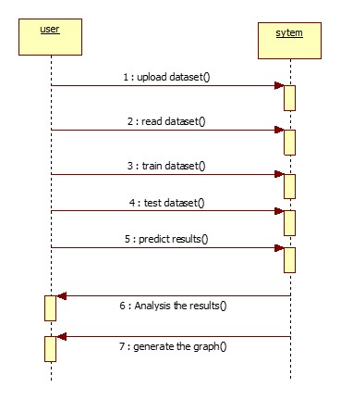

**Fig: 7.3**. Sequence Diagram

**ACTIVITY DIAGRAM:**

Activity diagrams are graphical representations of workflows of stepwise activities and actions with support for choice, iteration and concurrency. In the Unified Modeling Language, activity diagrams can be used to describe the business and operational step by step workflows of components in a system

uploqad dataset

read dataset

train dataset

test dataset

predict results

**Fig: 7.5.** Activity Diagram

**CHAPTER 7**

**SYSTEM TESTING**

The purpose of testing is to discover errors. Testing is the process of trying to discover every conceivable fault or weakness in a work product. It provides a way to check the functionality of components, sub-assemblies, assemblies and/or a finished product it is the process of exercising software with the intent of ensuring that the Software system meets its requirements and user expectations and does not fail in an unacceptable manner. There are various types of test. Each test type addresses a specific testing requirement.

**TESTING ACTIVITIES:**

**UNIT TESTING:**

Unit testing is usually conducted as part of a combined code and unit test phase of the software lifecycle, although it is not uncommon for coding and unit testing to be conducted as two distinct phases.

**TEST STRATEGY AND APPROACH:**

Field testing will be performed manually and functional tests will be written in detail.

**TEST OBJECTIVES:**

1. All field entries must work properly.
2. Pages must be activated from the identified link.
3. The entry screen, messages and responses must not be delayed.
4. Features to be tested
5. Verify that the entries are of the correct format
6. No duplicate entries should be allowed
7. All links should take the user to the correct page.

**INTEGRATION TESTING**

Integration testing is a level of software testing where individual units are combined and tested as a group.The purpose of this level of testing is to expose faults in the interaction between integrated units. Test drivers and test stubs are used to assist in Integration Testing.

**Test Results:** All the test cases mentioned above passed successfully. No defects encountered.

**ACCEPTANCE TESTING**

User Acceptance Testing is a critical phase of any project and requires significant participation by the end user. It also ensures that the system meets the functional requirements.

**Test Results:** All the test cases mentioned above passed successfully. No defects encountered.

**TEST CASES:**

|  |  |  |  |  |  |
| --- | --- | --- | --- | --- | --- |
| **TC NO** | **TEST SCENARIO** | **INPUT DATA** | **EXPECTED OUTPUT** | **ACTUAL OUTPUT** | **PASS/FAIL** |
| 1 | Valid input - General case | {"temperature": 25, "rainfall": 100, "soil_type": "Loamy", } | Predicted yield: 2500 kg/hectare | 2500 kg/hectare | PASS |
| 2 | Valid input - Different soil type | {"temperature": 28, "rainfall": 80, "soil_type": "Clay"} | Predicted yield 2000 kg/hectare | 2000 kg/hectare | PASS |
| 3 | Invalid input - Negative values | {"temperature": -5, "rainfall": -50, "soil_type":} | Error message: "Invalid input values" | Error message displayed | PASS |
| 4 | Invalid input - Missing fields | {"temperature": 22, "rainfall": 90} | Error message: "Missing required fields" | Error message displayed | PASS |
| 5 | Edge case - Extreme weather | {"temperature": 50, "rainfall": 5, "soil_type": "Sandy"} | Predicted yield: 500 kg/hectare | 500 kg/hectare | PASS |
| 6 | Valid input - Low rainfall | {"temperature": "high", "rainfall": "low"} | Predicted yield: 1500 kg/hectare | |  | | --- | | 1500 kg/hectare |  |  | | --- | |  | | PASS |
| 7 | Invalid input - Non-numeric values | {"temperature": 22, "rainfall": 500, "soil_type": "Clay"} | Predicted yield: 1500 kg/hectare | Error message displayed | PASS |
| 8 | Edge case - Very high rainfall | {"temperature": 24, "rainfall": 90, "soil_type": "Silt",} | Predicted yield: 3000 kg/hectare | 3000 kg/hectare | PASS |

**CHAPTER 8**

**CONCLUSION**

* 1. **Conclusion**

In conclusion, the Decision Tree algorithm proves to be an effective and intuitive method for predicting crop yield, as it adeptly models the complex relationships between key agricultural factors such as area, rainfall, temperature, pesticide usage, and crop type. By analyzing these variables, decision trees offer valuable insights that can help farmers and agricultural experts make informed decisions, optimizing farming practices and improving crop management strategies. The interpretability of decision trees allows stakeholders to understand the decision-making process easily, facilitating the application of data-driven insights in real-world scenarios.

However, it is essential to recognize the limitations of decision trees, including their susceptibility to overfitting and sensitivity to minor variations in the dataset. To enhance the model's robustness, techniques such as pruning and cross-validation should be employed. Performance metrics like Mean Absolute Error (MAE), Root Mean Squared Error (RMSE), and R-squared values are crucial in assessing prediction accuracy. By comparing decision trees with other machine learning models, stakeholders can select the most suitable algorithm for their specific agricultural needs. Ultimately, incorporating decision tree algorithms into crop yield prediction can empower stakeholders to address challenges in agriculture, contributing to food security and sustainability in an everchanging environment.

* 1. **Future Enhancements**

The future of crop yield prediction (CYP) using decision trees offers substantial opportunities for enhancement, driven by technological advancements and increasing data availability. One significant direction for improvement is the integration of advanced machine learning techniques, such as Random Forests and Gradient Boosting Machines (GBM). These ensemble methods can enhance the predictive accuracy of decision trees by aggregating the predictions of multiple trees, thereby reducing the risk of overfitting and improving the model's generalization capabilities. This hybrid approach can provide more reliable insights into crop yields under varying agricultural conditions.

Additionally, the utilization of big data and Internet of Things (IoT) technologies holds great potential for real-time data collection from the field. Sensors can provide continuous monitoring of critical factors like soil moisture, temperature, and humidity, allowing for timely adjustments in farming practices. Moreover, incorporating remote sensing technologies and Geographic Information Systems (GIS) can enhance decision-making by providing spatial data, such as satellite imagery that tracks crop health and growth patterns over large areas. These advancements enable farmers to make informed, data-driven decisions, ultimately leading to improved crop management.

Collaboration between data scientists, agronomists, and farmers is also essential for the successful enhancement of crop yield prediction models. By working together, these stakeholders can validate models and ensure that predictions align with practical farming experiences and challenges. Furthermore, developing user-friendly decision support systems that leverage crop yield prediction models can empower farmers with actionable insights tailored to their specific agricultural conditions. As the agricultural sector embraces these advancements, it will not only enhance productivity and resource utilization but also contribute to greater food security and sustainability in a rapidly evolving global landscape.

**APPENDICES:**

**A.1 CODING**

**BACKEND CODING:**

import numpy as np *# linear algebra* import pandas as pd *# data processing, CSV file I/O (e.g. pd.read_csv)* import seaborn as sns import matplotlib.pyplot as plt df=pd.read_csv('yield_df.csv') df.head()

def isStr(obj): try:

float(obj) return False except: return True country = df['Area'].unique() yield_per_country = [] for state in country:

yield_per_country.append(df[df['Area']==state]['hg/ha_yield'].sum()) crops = df['Item'].unique() yield_per_crop = [] for crop in crops:

yield_per_crop.append(df[df['Item']==crop]['hg/ha_yield'].sum()) sns.barplot(y=crops,x=yield_per_crop)

col = ['Year', 'average_rain_fall_mm_per_year','pesticides_tonnes', 'avg_temp', 'Area',

'Item', 'hg/ha_yield'] df = df[col] X = df.iloc[:, :-1] y = df.iloc[:, -1] from sklearn.model_selection import train_test_split

X_train, X_test, y_train, y_test = train_test_split(X, y, train_size=0.8, random_state=0, shuffle=True) from sklearn.preprocessing import OneHotEncoder from sklearn.compose import ColumnTransformer from sklearn.preprocessing import StandardScaler ohe = OneHotEncoder(drop='first') scale = StandardScaler()

preprocesser = ColumnTransformer( transformers = [

('StandardScale', scale, [0, 1, 2, 3]),

('OHE', ohe, [4, 5]),

], remainder='passthrough'

)

X_train_dummy = preprocesser.fit_transform(X_train) X_test_dummy = preprocesser.transform(X_test)

preprocesser.get_feature_names_out(col[:-1])

from sklearn.linear_model import LinearRegression,Lasso,Ridge from sklearn.neighbors import KNeighborsRegressor from sklearn.tree import DecisionTreeRegressor from sklearn.metrics import mean_absolute_error,r2_score models = {

'lr':LinearRegression(),

'lss':Lasso(),

'Rid':Ridge(),

'Dtr':DecisionTreeRegressor()

} for name, md in models.items(): md.fit(X_train_dummy,y_train) y_pred = md.predict(X_test_dummy)

print(f"{name} : mae : {mean_absolute_error(y_test,y_pred)} score :

{r2_score(y_test,y_pred)}") dtr = DecisionTreeRegressor() dtr.fit(X_train_dummy,y_train) dtr.predict(X_test_dummy)

def prediction(Year, average_rain_fall_mm_per_year, pesticides_tonnes, avg_temp, Area, Item):

# Create an array of the input features

features = np.array([[Year, average_rain_fall_mm_per_year, pesticides_tonnes, avg_temp, Area, Item]], dtype=object)

def prediction(Year, average_rain_fall_mm_per_year, pesticides_tonnes, avg_temp, Area, Item):

*# Create an array of the input features*

features = np.array([[Year, average_rain_fall_mm_per_year, pesticides_tonnes, avg_temp, Area, Item]], dtype=object)

*# Transform the features using the preprocessor* transformed_features = preprocesser.transform(features)

*# Make the prediction*

predicted_yield = dtr.predict(transformed_features).reshape(1, -1)

return predicted_yield[0]

*# Transform the features using the preprocessor* transformed_features = preprocesser.transform(features)

*# Make the prediction*

predicted_yield = dtr.predict(transformed_features).reshape(1, -1)

return predicted_yield[0

def prediction(Year, average_rain_fall_mm_per_year, pesticides_tonnes, avg_temp, Area,

Item):

*# Create an array of the input features*

features = np.array([[Year, average_rain_fall_mm_per_year, pesticides_tonnes, avg_temp, Area, Item]], dtype=object)

*# Transform the features using the preprocessor* transformed_features = preprocesser.transform(features)

*# Make the prediction*

predicted_yield = dtr.predict(transformed_features).reshape(1, -1)

return predicted_yield[0] import pickle

pickle.dump(dtr,open('dtr.pkl','wb'))

pickle.dump(preprocesser,open('preprocessor.pkl','wb'))

**APP.PY:**

from flask import Flask, request, render_template import numpy as np import pickle import sklearn

*# Print sklearn version for debugging purposes* print(sklearn.__version__)

*# Loading models*

dtr = pickle.load(open('dtr.pkl', 'rb'))

preprocessor = pickle.load(open('preprocessor.pkl', 'rb'))

*# Flask app*

app = Flask(__name__)

@app.route('/') def index():

return render_template('Index.html')

@app.route("/predict", methods=['POST']) def predict(): if request.method == 'POST':

*# Convert form inputs to the appropriate data types*

Year = int(request.form['Year']) average_rain_fall_mm_per_year =

float(request.form['average_rain_fall_mm_per_year'])

pesticides_tonnes = float(request.form['pesticides_tonnes'])

avg_temp = float(request.form['avg_temp'])

Area = str(request.form['Area'])

Item = str(request.form['Item'])

*# Create feature array and preprocess*

features = np.array([[Year, average_rain_fall_mm_per_year, pesticides_tonnes, avg_temp, Area, Item]], dtype=object)

transformed_features = preprocessor.transform(features)

*# Make prediction*

prediction = dtr.predict(transformed_features)

*# Render the result in the template*

return render_template('Index.html', prediction=prediction)

if __name__ == "__main__": app.run(debug=True)

**INDEX.HTML:**

<!DOCTYPE html>

<html lang="en">

<head>

<meta charset="UTF-8">

<meta name="viewport" content="width=device-width, initial-scale=1.0">

<title>Crop Yield Prediction</title>

<link rel="stylesheet" href="../static/styles.css">

<link

href="https://fonts.googleapis.com/css2?family=Playfair+Display:wght@500&family=Poppins

:wght@300;600&display=swap" rel="stylesheet">

</head>

<body>

<div class="overlay">

<header class="header">

<h1>CROP YIELD PREDICTION USING ML ALGORITHM</h1>

<p class="authors">Made by Saima Nooreen and Samyuktha</p>

</header>

<section class="content">

<div class="image-container">

*<!-- Button with updated class -->*

<a href="predict.html" class="predict-button">Predict Now</a> </div>

</section>

</div>

</body>

</html>

**PREDICT.HTML:**

<!doctype html>

<html lang="en">

<head>

<meta charset="utf-8">

<meta name="viewport" content="width=device-width, initial-scale=1">

<title>Crop Yield Prediction</title>

<link

href="https://cdn.jsdelivr.net/npm/bootstrap@5.3.0/dist/css/bootstrap.min.css" rel="stylesheet" integrity="sha384-

9ndCyUaIbzAi2FUVXJi0CjmCapSmO7SnpJef0486qhLnuZ2cdeRhO02iuK6FUUVM" crossorigin="anonymous">

<style>

*/* Set background image for the body */* body {

background-image: url('https://www.shutterstock.com/image-photo/green-ripeningsoybean-field-agricultural-260nw-759949660.jpg'); */* Updated image URL */* background-size: cover; background-repeat: no-repeat; background-position: center; background-attachment: fixed;

color: white; */* To ensure text remains readable */*

}

*/* Additional styles to enhance readability */*

.container {

background-color: rgba(0, 0, 0, 0.6); */* Dark overlay to improve text visibility */*

border-radius: 20px; padding: 20px; color: white;

}

*/* Hide the analysis image by default */*

#analysis-image { display: none; margin-top: 20px; border-radius: 10px; max-width: 100%;

}

</style>

</head>

<body>

<h1 class="text-center text-success">Crop Yield Prediction Per Country</h1>

<div class="container my-4 mt-4">

<h1 class="text-center text-danger">Input All Features Here</h1>

*<!-- Form for crop yield prediction -->* <form action="/predict" method="post">

<div class="form-group">

<label for="Year">Year</label>

<input type="number" class="form-control" name="Year" step="any" value="2013"> </div>

<div class="form-group">

<label for="average_rain_fall_mm_per_year">Average Rainfall (mm per year)</label>

<input type="number" class="form-control" name="average_rain_fall_mm_per_year" step="any">

</div>

<div class="form-group">

<label for="pesticides_tonnes">Pesticides (Tonnes)</label> <input type="number" class="form-control" name="pesticides_tonnes" step="any">

</div>

<div class="form-group">

<label for="avg_temp">Average Temperature</label>

<input type="number" class="form-control" name="avg_temp" step="any"> </div>

<div class="form-group">

<label for="Area">Area</label>

<input type="text" class="form-control" name="Area">

</div>

<div class="form-group">

<label for="Item">Item</label>

<input type="text" class="form-control" name="Item">

</div>

<button type="submit" class="btn btn-danger btn-lg mt-2 btnblock">Predict</button>

</form>

*<!-- Flask template to display prediction result -->*

{% if prediction %}

<h1 class="text-center mt-4">Predicted Yield: {{ prediction[0][0] }}</h1> {% endif %}

*<!-- "Analysis" button to show the image -->*

<div class="text-center my-4">

<button id="analysis-button" class="btn btn-primary btn-lg">Show

Analysis</button>

</div>

*<!-- Image that appears when the Analysis button is clicked -->*

<div class="text-center"> <img id="analysis-image"

src="https://www.frontiersin.org/files/Articles/452963/fpls-10-00621-HTML/image_m/fpls-

10-00621-g006.jpg" alt="Analysis Image"> *<!-- Updated valid image URL -->* </div>

</div>

<script>

*// JavaScript to toggle image visibility when the button is clicked*

document.getElementById('analysis-button').addEventListener('click', function() { var image = document.getElementById('analysis-image');

image.style.display = (image.style.display === 'none' || image.style.display

=== '') ? 'block' : 'none'; *// Fix toggle visibility logic*

});

</script>

<script

src="https://cdn.jsdelivr.net/npm/bootstrap@5.3.0/dist/js/bootstrap.bundle.min.js" integrity="sha384-geWF76RCwLtnZ8qwWowPQNguL3RmwHVBC9FhGdlKrxdiJJigb/j/68SIy3Te4Bkz" crossorigin="anonymous"></script>

</body>

</html>

**A.2 ANALYSIS:**

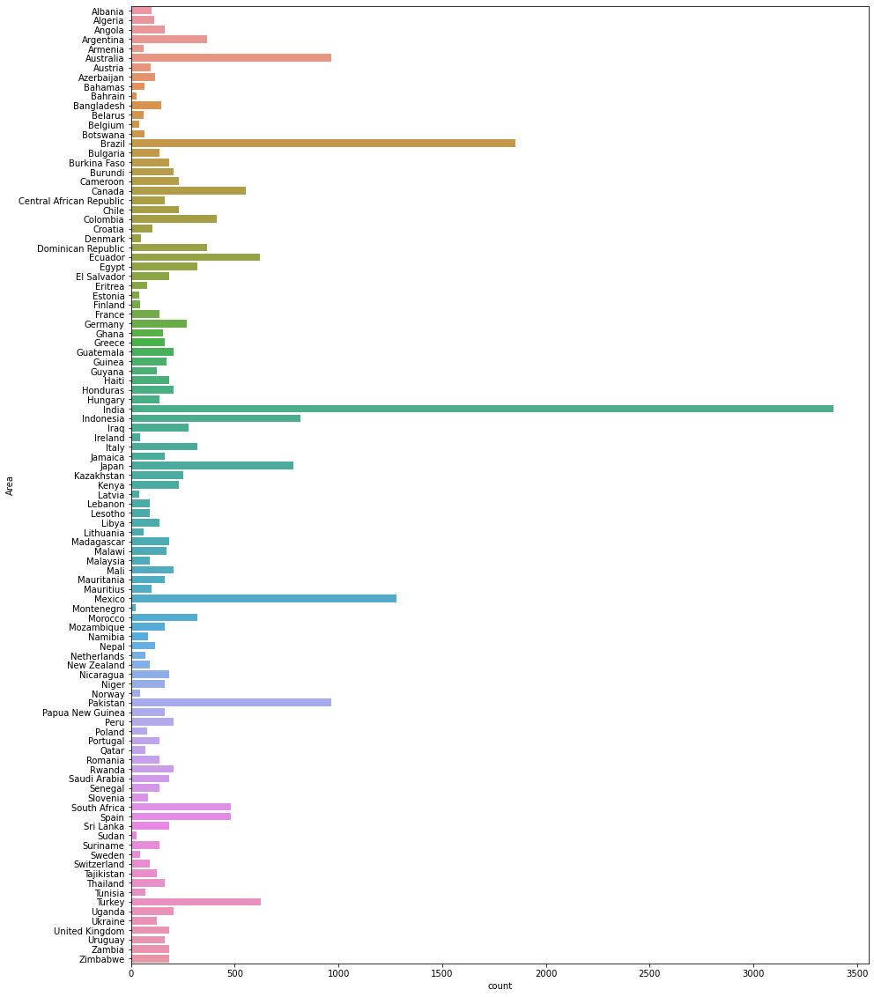

*fig A.2.1 Country wise statistics*

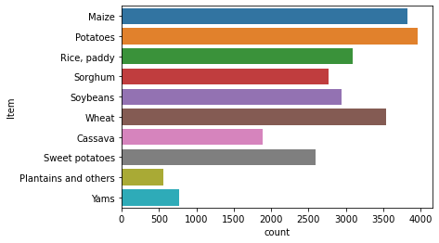

*fig A.2.2 Before Training Analysis*

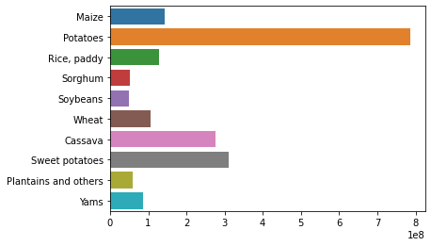

*fig A.2.3 After Training Analysis*

**A.3 SAMPLE SCREENS:**

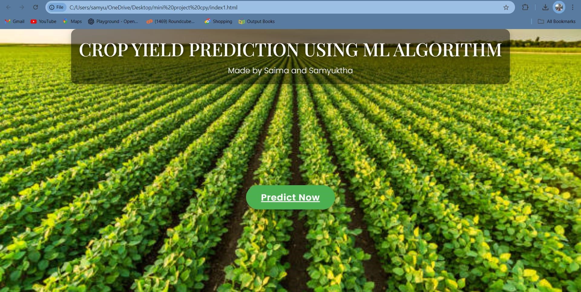

*fig A.3.1 Welcome page*

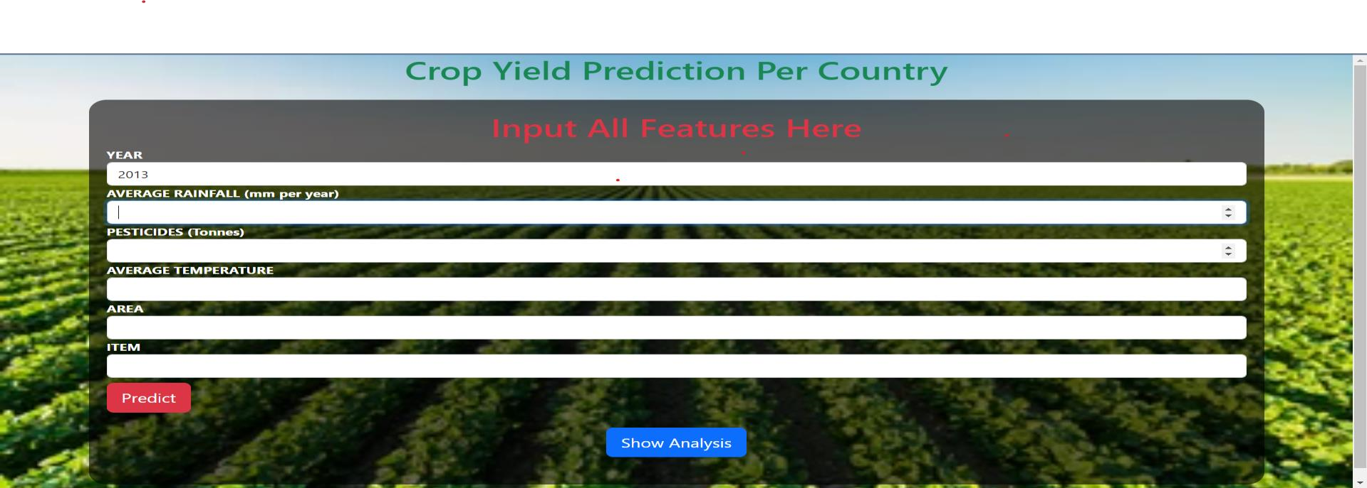

*fig A.3.2 Prediction page*

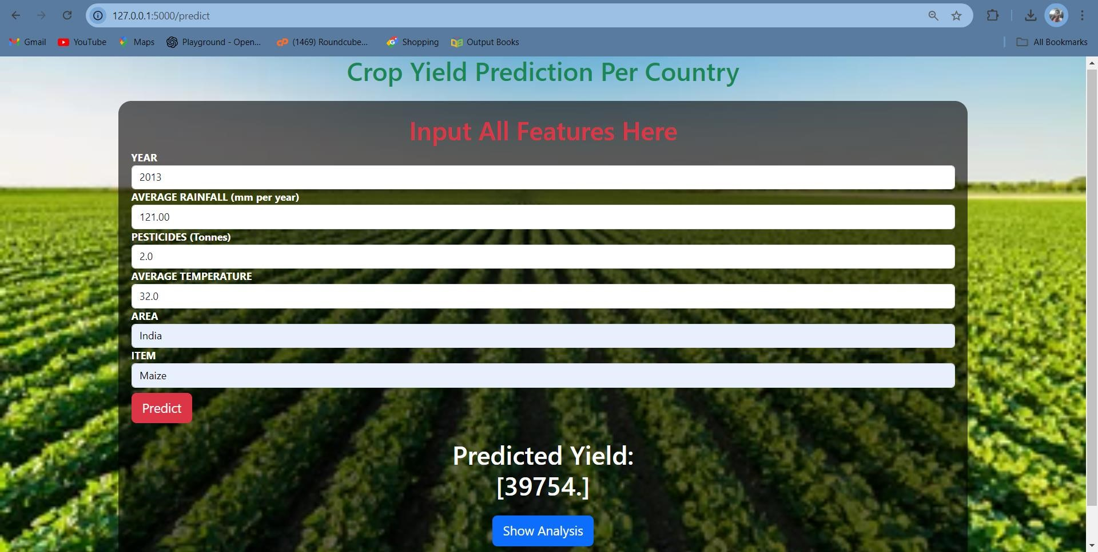

*fig A.3.3 Predicted Yield*

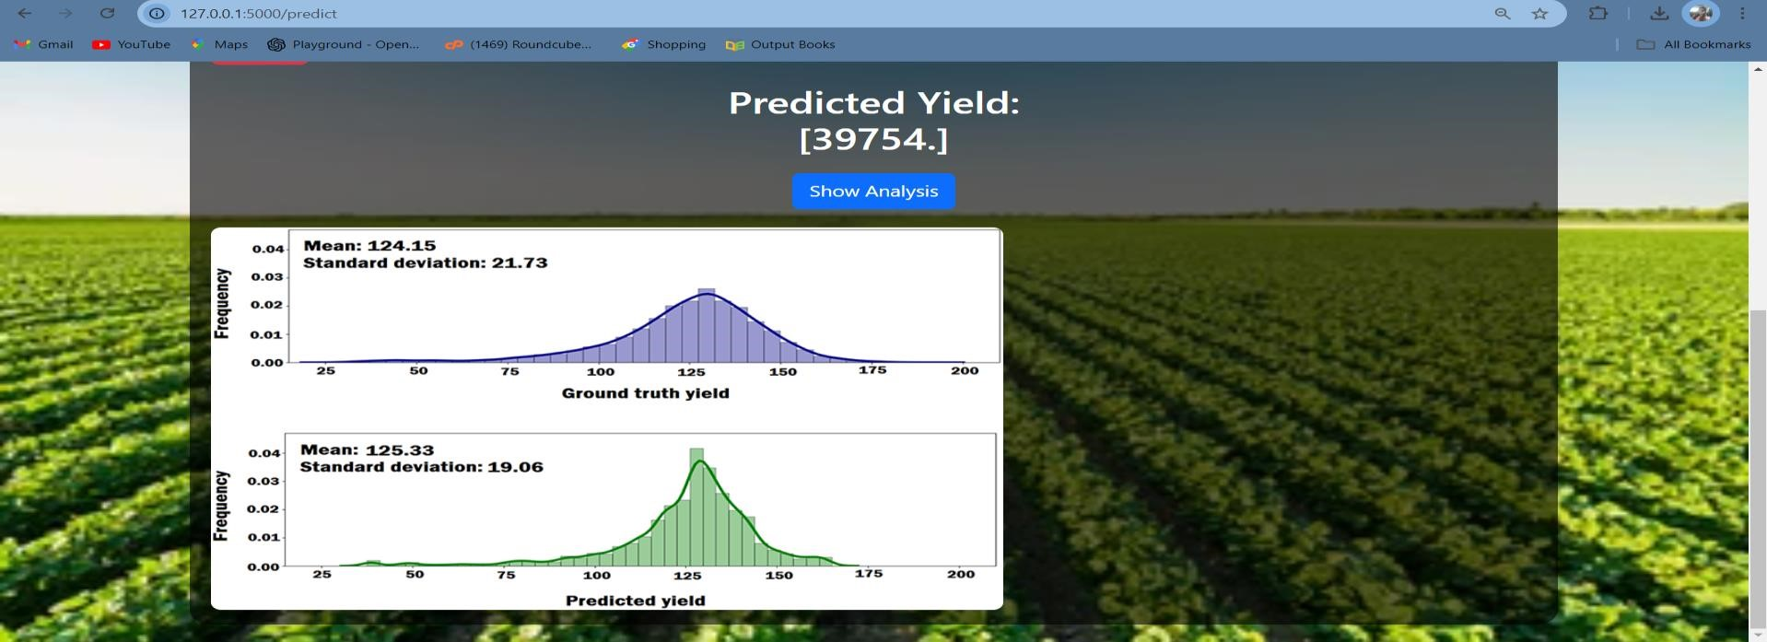

*fig A.3.4 Graphical Analysis*

**REFERENCES**

1. Shivam Bang, Akshaya Kumar Dixit Rajat Bishnoi, Indu Chawla,Ankit Singh Chauhan, “Predicting Crop Yield using Fuzzy Logic using ARMA, SARIMA, and ARMAX Model Predicted Temperature and Rainfall Parameters, IEEE-2019
2. Aruvansh Nigam, Saksham Garg, Parul Agarwal, Archit Agarwal.“Crop yield prediction in Indian agriculture using machine learning”,
3. Potnuru Sai Nishant, Pinapa Sai Venkat, and Bollu Lakshmi Avinash B., “Crop Yield Prediction based on Indian Agriculture using Machine Learning"
4. Dhivya Elavarasan and P. M. Durairaj Vincent., “Crop yield prediction using a deep reinforcement learning model for environmentally responsible agricultural applications”,IEEE.
5. Niketa Gandhi, Owaiz Petkar, Leisa J. Armstrong, and Amiya Kumar Tripathy "Rice Crop Yield Prediction in India UsingSupport Vector Machines,"
6. Snehal S. Dahikar and Sandeep V. Rode's Article "Agricultural Crop Yield Prediction Using Artificial Neural Network Approach"published in the international journal of creative research
7. D. Ramesh and B. Vishnu Vardhan, Analysis of crop yield prediction utilising data mining techniques, International Journal of Research in Engineering and Technology
8. B. Manjula Josephine; K. Ruth Ramya; K.V.S.N. Rama Rao;Swarna Kuchibhotla; P.Venkata Bala Kishore; S. Rahamathulla;“Crop yield prediction using machine learning”; international journal of scientific & technology research
9. M. J. and I. M., "Hybrid filter and wrapper approaches-based feature selection for crop recommendation." 2020 International Conference on Electronic Systems and Intelligent Computing (ICESIC),